DoS Attack to the DNS Server

(Using Spoofed IP Address)

Final Report & Implementation Demo

**Source Code:** <https://github.com/shiroe41/DoS-Attack-to-the-DNS-Server.git>

**Attack Strategy:** We will execute the DoS attack with **DNS NXDOMAIN Flood attack** approach. With this approach, the DNS server is flooded with non-existent domain-name requests which makes the DNS cache overflow, and the server uses up all its resources to query these domain-names and thus becomes unable to answer DNS query to valid clients. We will also spoof the IP address of the attacker so that the attacker cannot be traced.

We will be using Oracle VM VirtualBox to simulate this attack and some prevention measures.

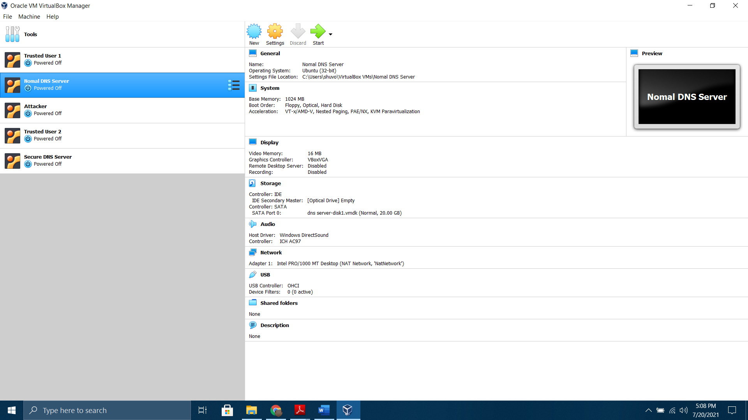

So, here we created 5 virtual machines. We will use the **Attacker**, **Trusted User 1** and **Normal DNS Server** to simulate the DoS attack. After that we will use the **Attacker**, **Trusted User 2** and **Secure DNS Server** to simulate some prevention measures.

**Attack Steps:**

* The DNS query packet is built with appropriate header values and question segment. A randomly generated garbage domain name is used to build the question segment. The format used is xxxxx.xxxxx.xxxxx
* IP header with spoofed IP Address and UDP header is created. The DNS Packet is the payload here. All of them are concatenated into a single packet.
* Then the packet is sent to the target DNS server.
* This process is run in an infinite loop.
* This attack is executed from the terminal as superuser, and it can be terminated with

CTRL+c keyboard command.

**Snapshots of the Attack:**

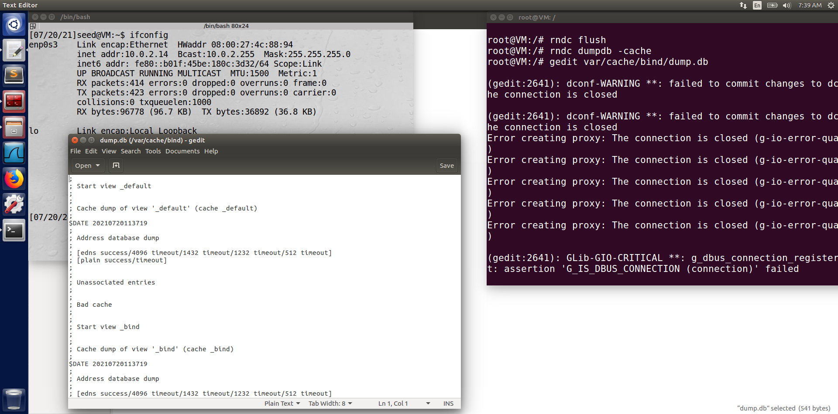

This is the initial state of the **Normal DNS Server** machine. We can see its IP address is 10.0.2.14 Its DNS cache size is 541 bytes, and it contains no record for the time being. Now we use 'dig' command from **Trusted User 1** to send a valid DNS query and see the changes.

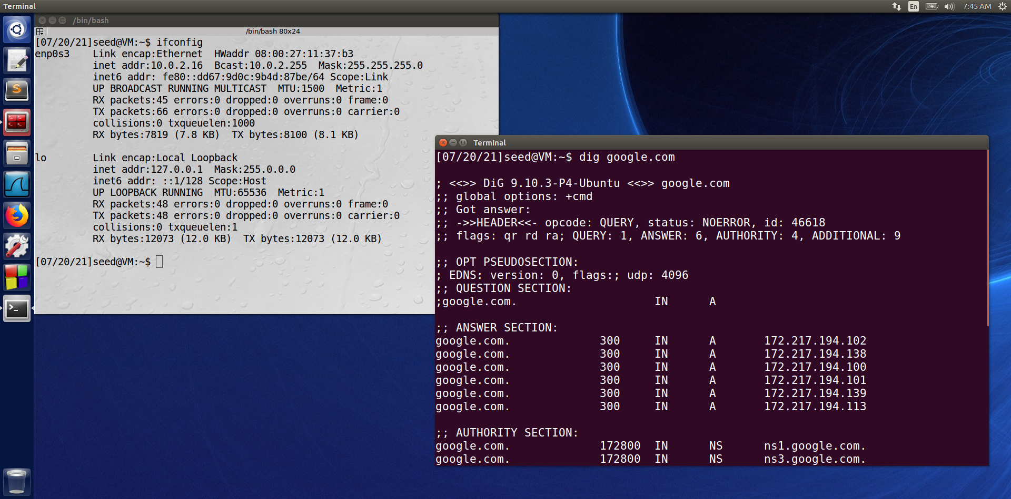

This is **Trusted User 1** machine with IP address 10.0.2.16; We can see the 'dig' command executed successfully and we got a valid DNS response. Now let’s check the server’s status.

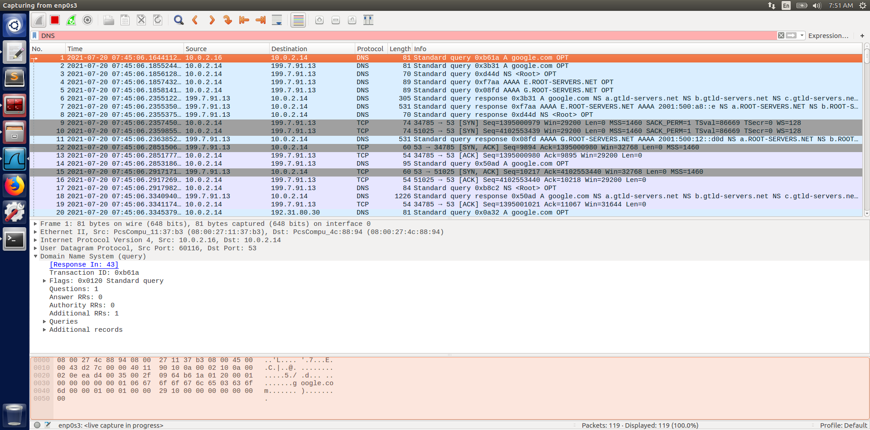

We can check the packets in Wireshark. Here we can see a DNS query about google.com from Source 10.0.2.16 to Destination 10.0.2.14 which is the machine itself. Now if we check the DNS cache status,

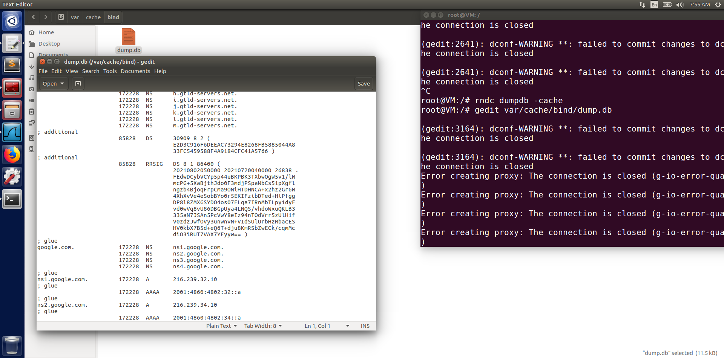

We can see the entry google.com in the DNS cache and the cache size increased to 11.5 KB. Now we will start the DoS attack and see what happens.

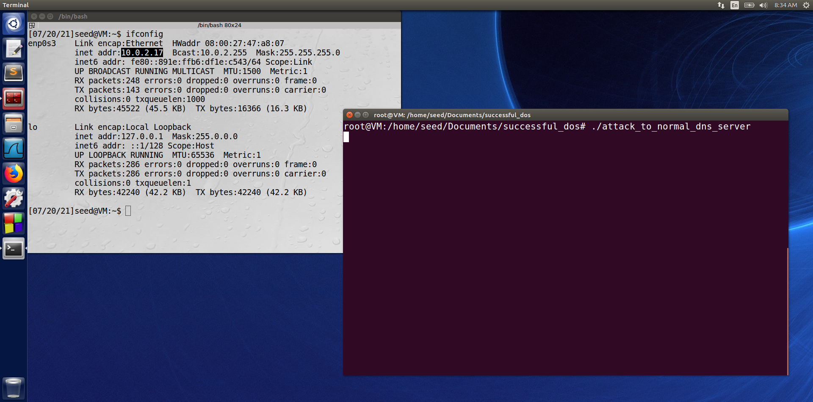

This is the **Attacker** machine with IP address 10.0.2.17; We start the DoS attack from here. Now let’s check the server using Wireshark

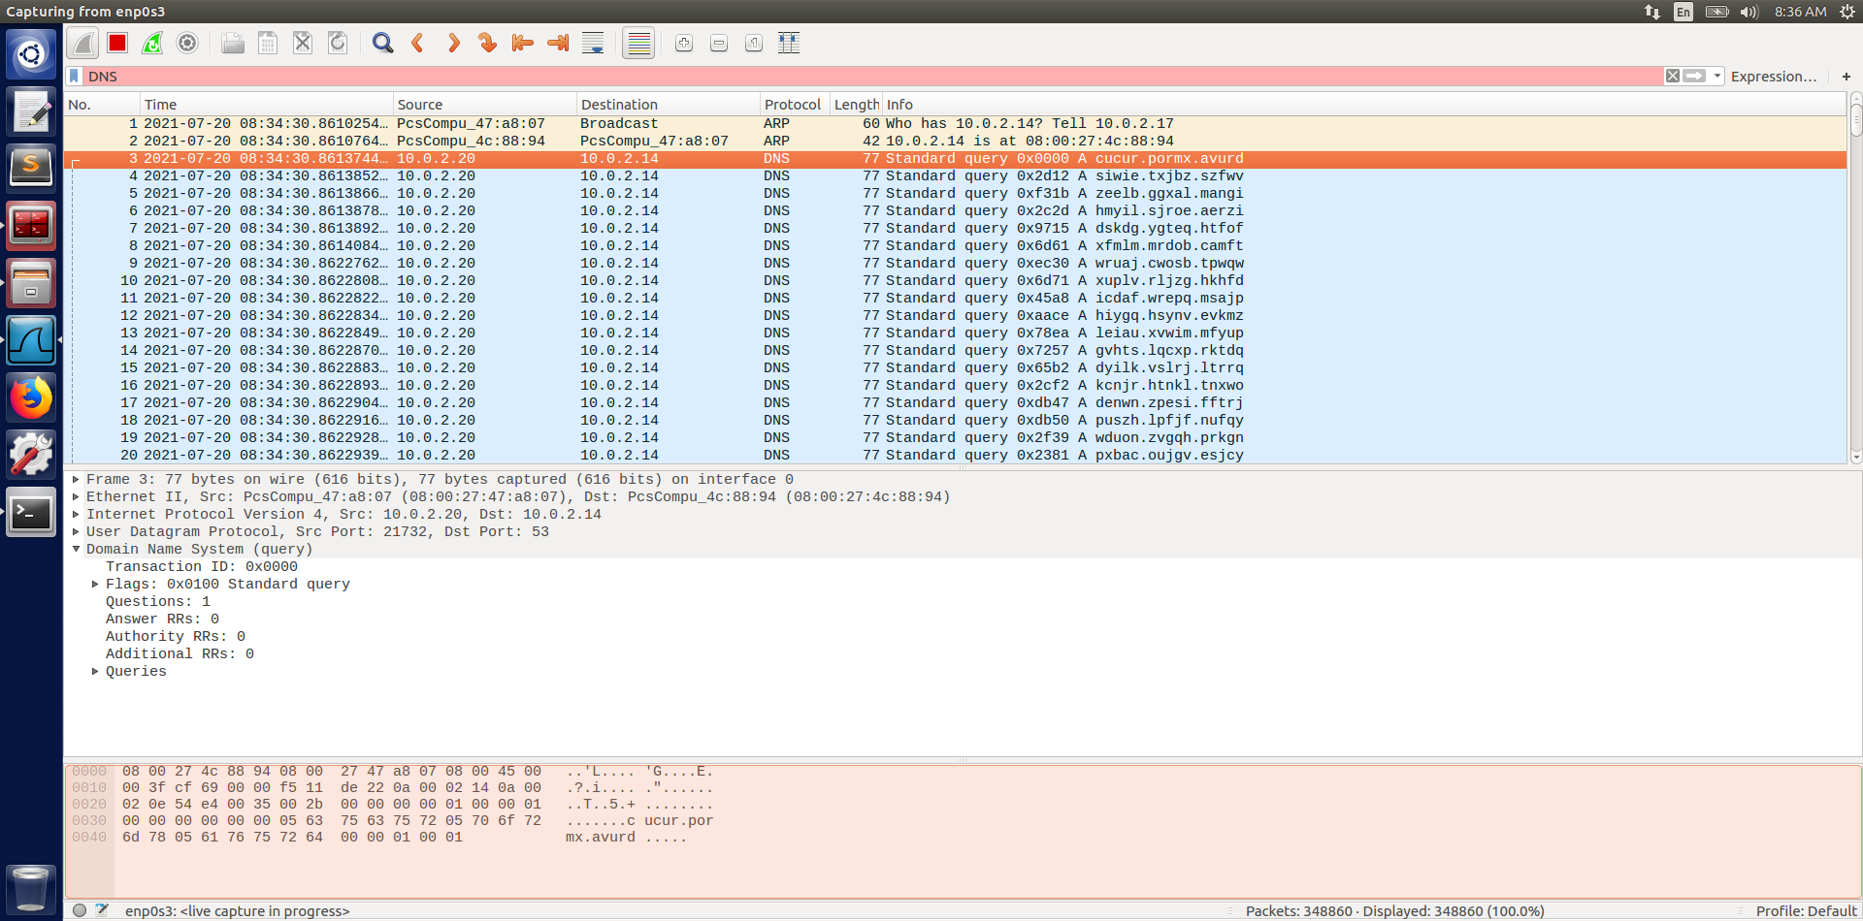

We can see, the server is flooded with garbage DNS queries from IP address 10.0.2.20 which is not the attacker’s own IP address. So, IP spoofing was successful. Now let’s check the Client machine and try to use 'dig' command like before.

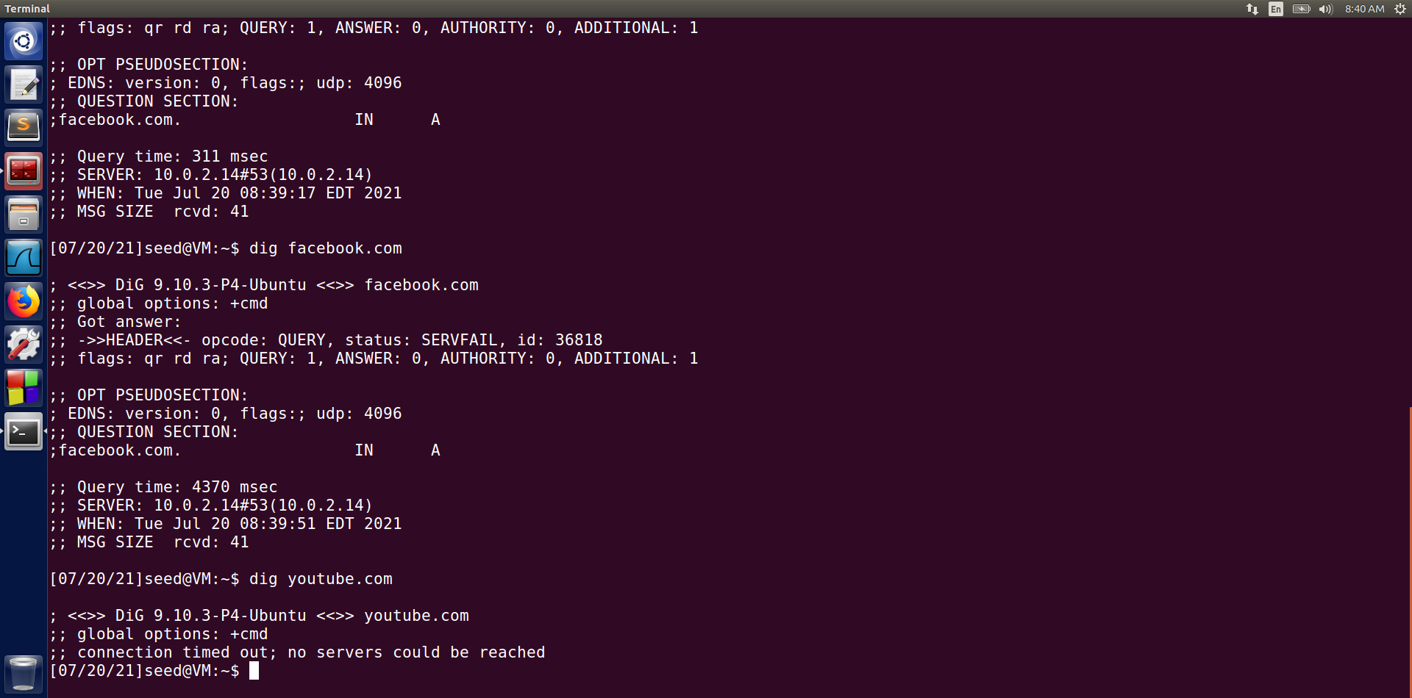

We can see all the requests failed with either **SERVFAIL** status or **Connection Timed Out** Status. So, the client is successfully being denied of service. Let’s stop the attack and check the server cache.

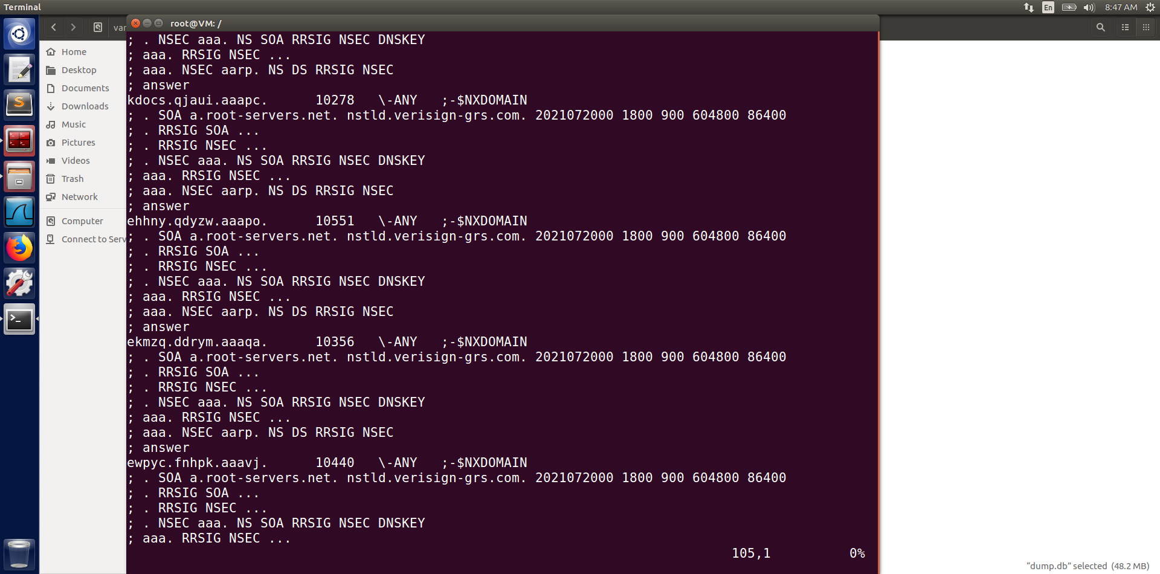

We can see the cache is filled with NXDOMAIN entries from the attack. Its size has increased to 48.2 MB. Now that we stopped the attack, let’s try to use 'dig' command from the **Trusted User 1** machine again.

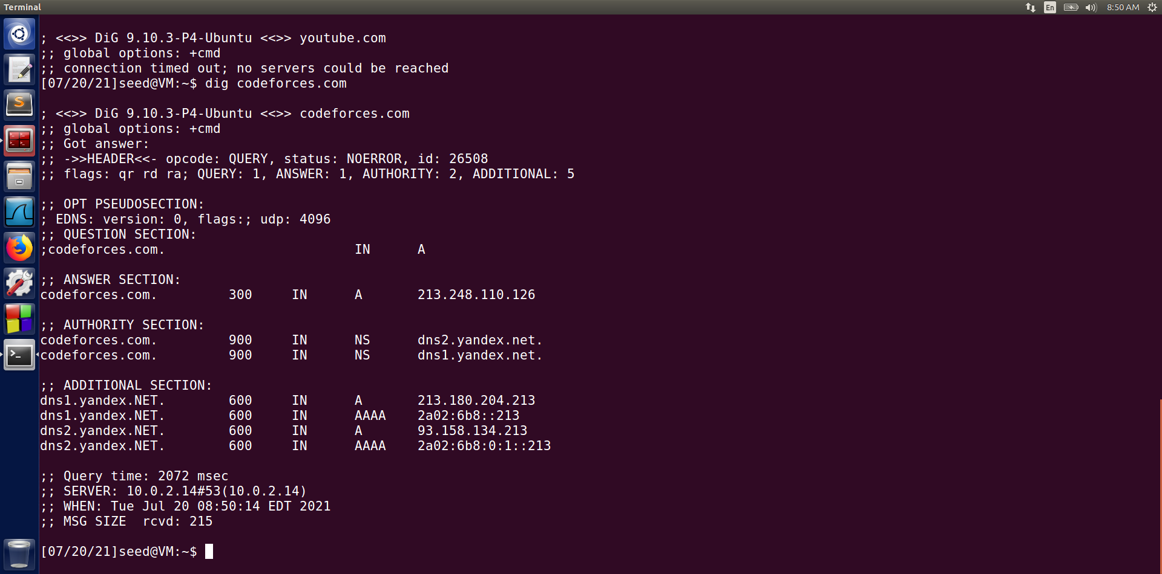

We can see the command is working again just as it was before.

**So, from the observation above, we can say that the DoS attack is working perfectly.**

**Snapshots of Attack on a Secured DNS Server:**

Here we will target the **Secure DNS Server** machine for our attack. The client will be **Trusted User 2,** and the attacker will be same as before.

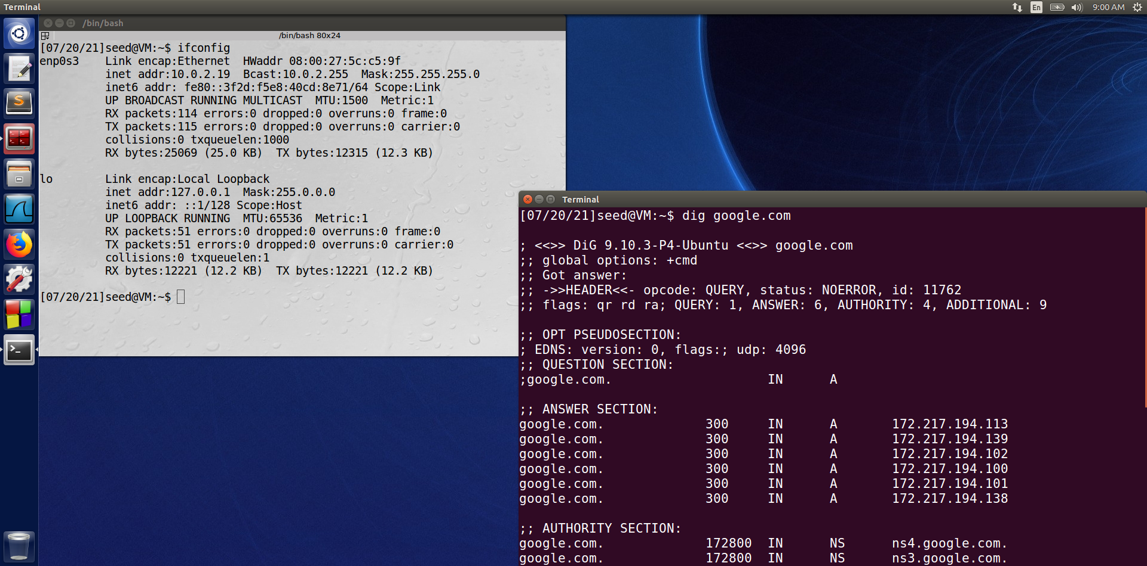

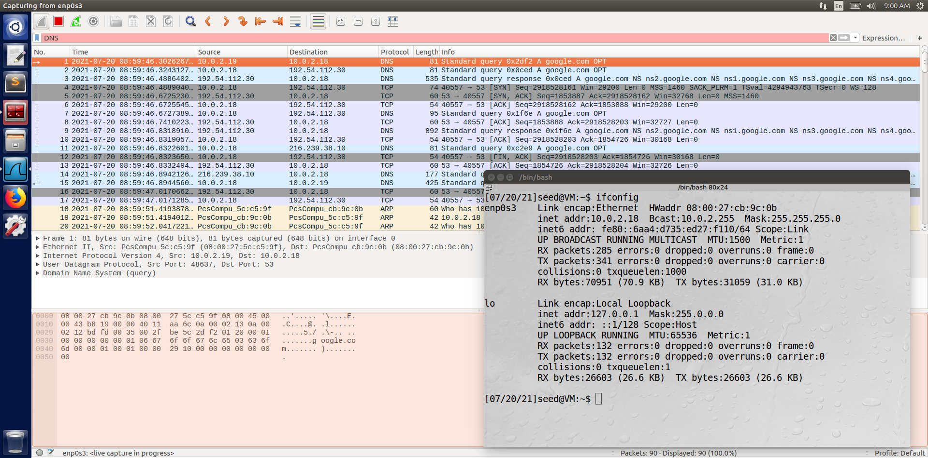

So, we can see the **Trusted User 2** machine has IP address 10.0.2.19 and sends DNS query to **Secured DNS Server** machine with IP address 10.0.2.18; The query is resolved, and the client got the DNS response. Now, we will start the attack.

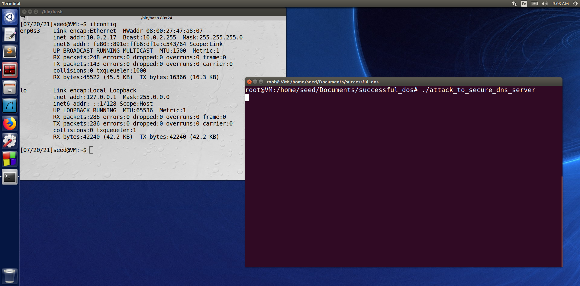

Here, we started the DoS attack. Let’s check the DNS server status with Wireshark.

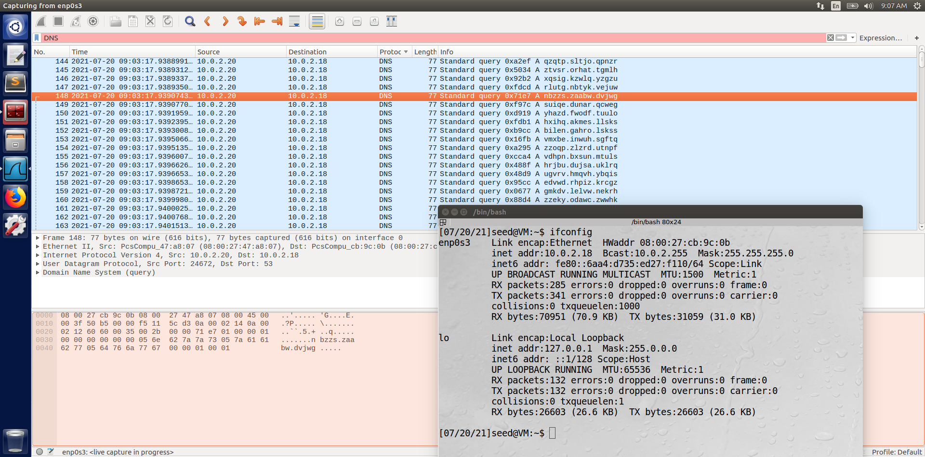

We can see the server is flooded with garbage domain-name queries from IP address 10.0.2.20

Let’s check the client machine to see if we can still get response using 'dig' command.

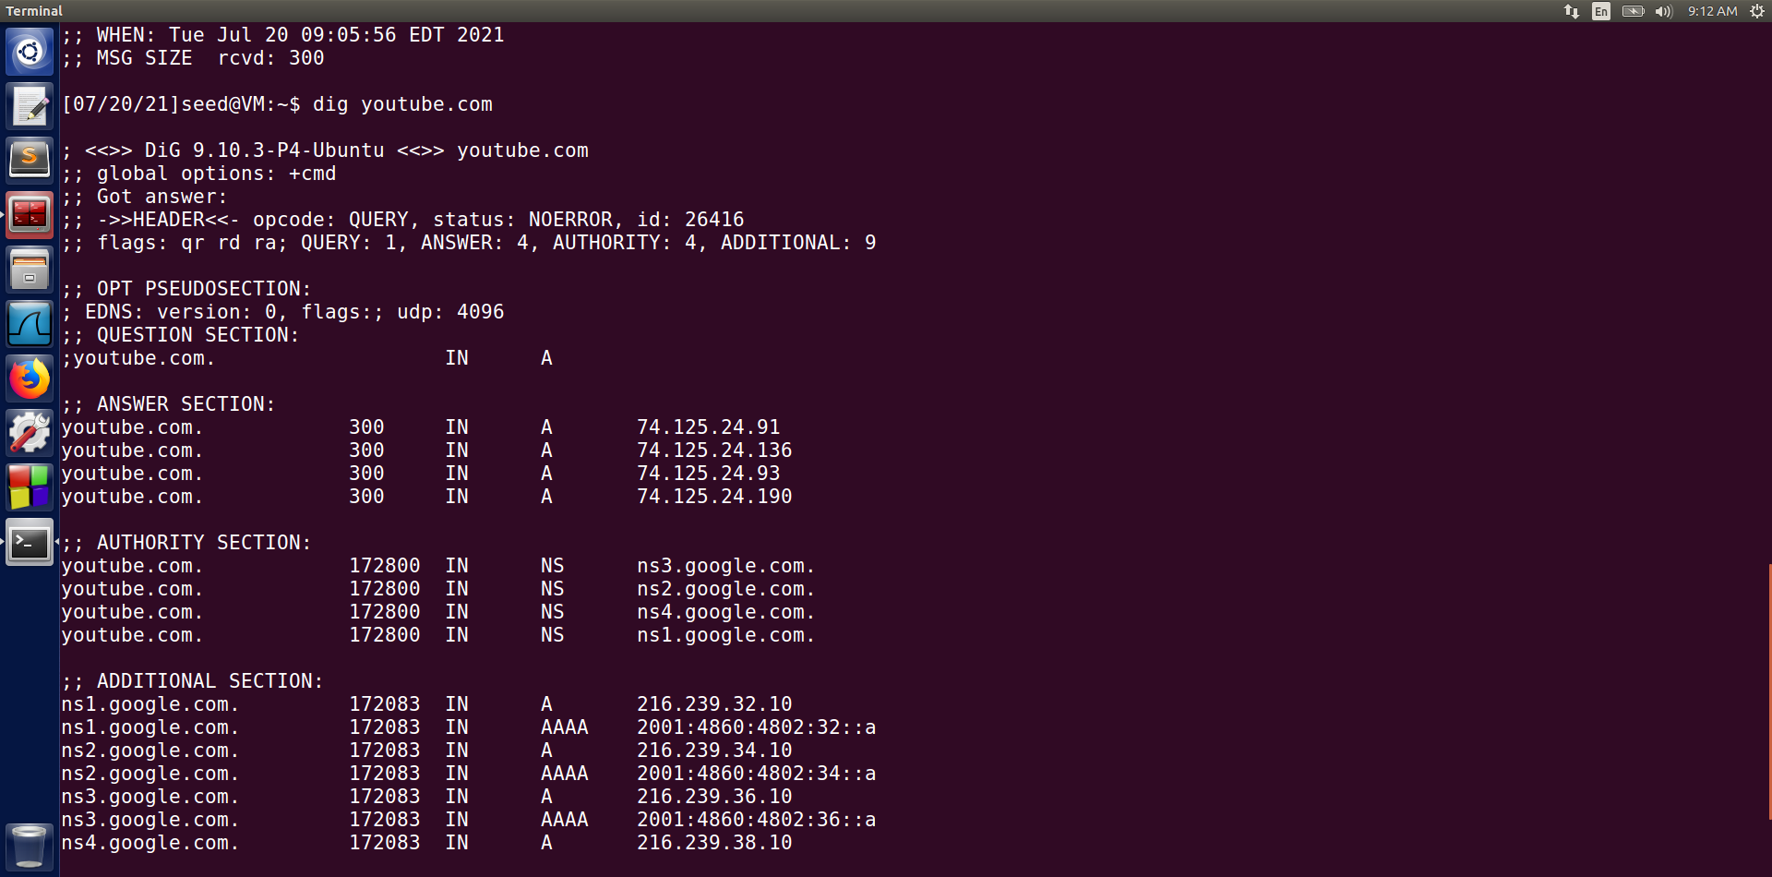

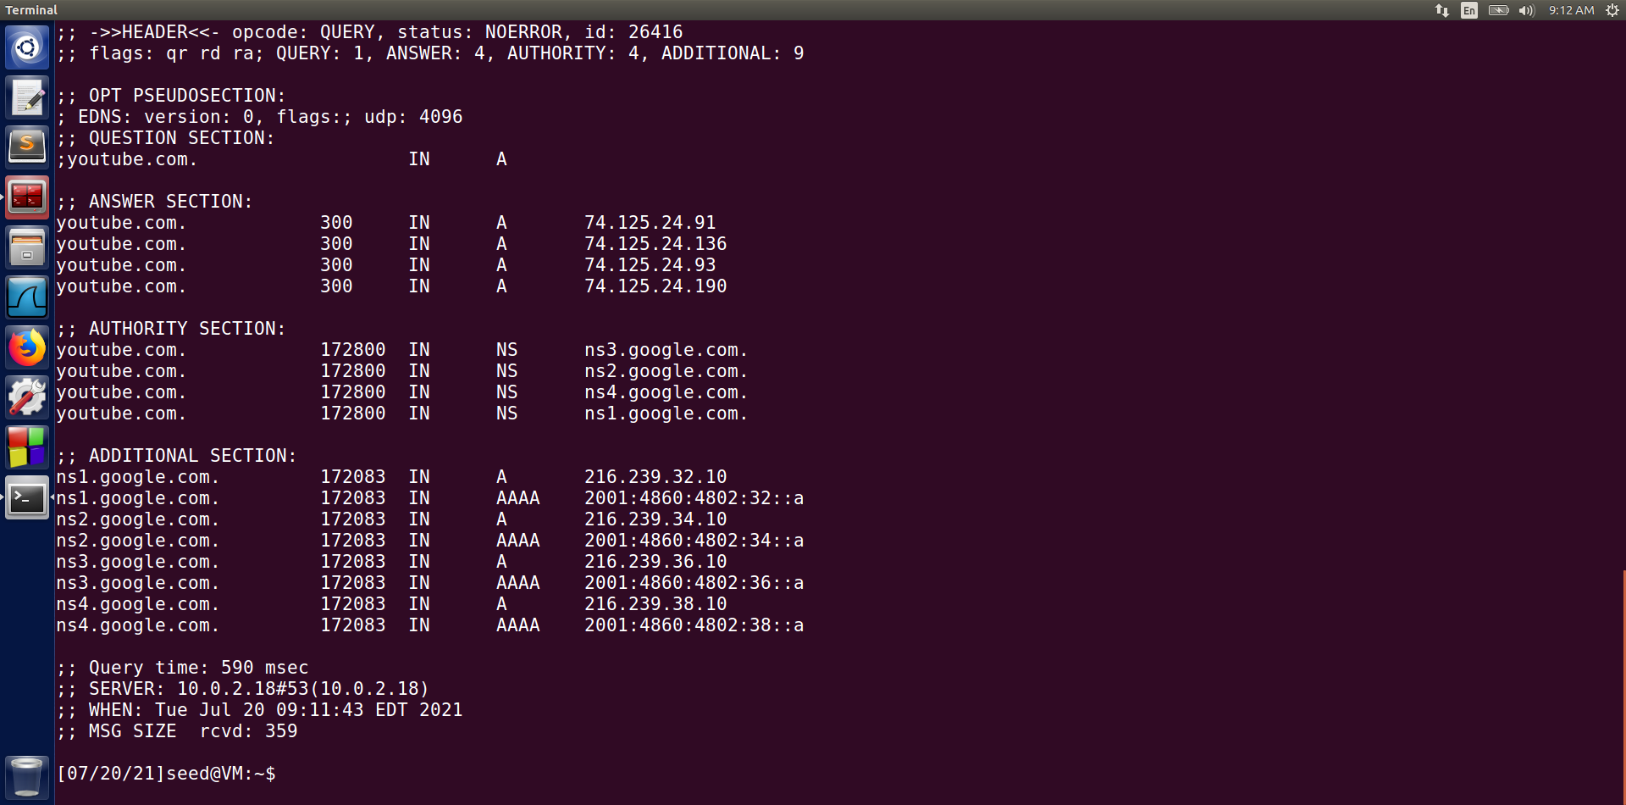

So, we can see that we are still getting response in reasonable time despite the DoS attack. Let’s stop the attack and check server’s DNS cache.

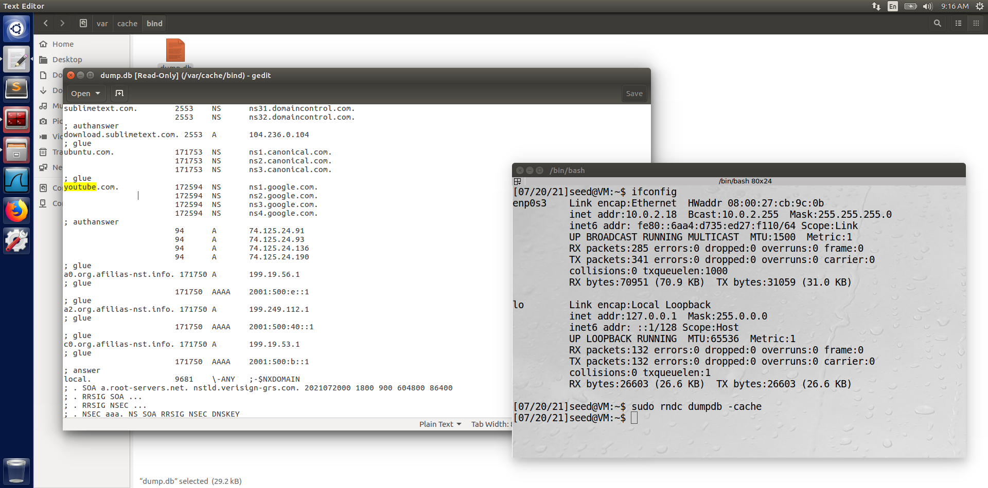

We can see the cache is unaffected by the DoS attack and thus no NXDOMAIN entries. Its size is now only 29.2 KB.

**So, from the above observation we can say that the DoS attack is successfully prevented.**

To achieve this, I had to make some changes in the /etc/bind/named.conf.options file. Below both normal and secure server’s file snapshot is given for comparison.

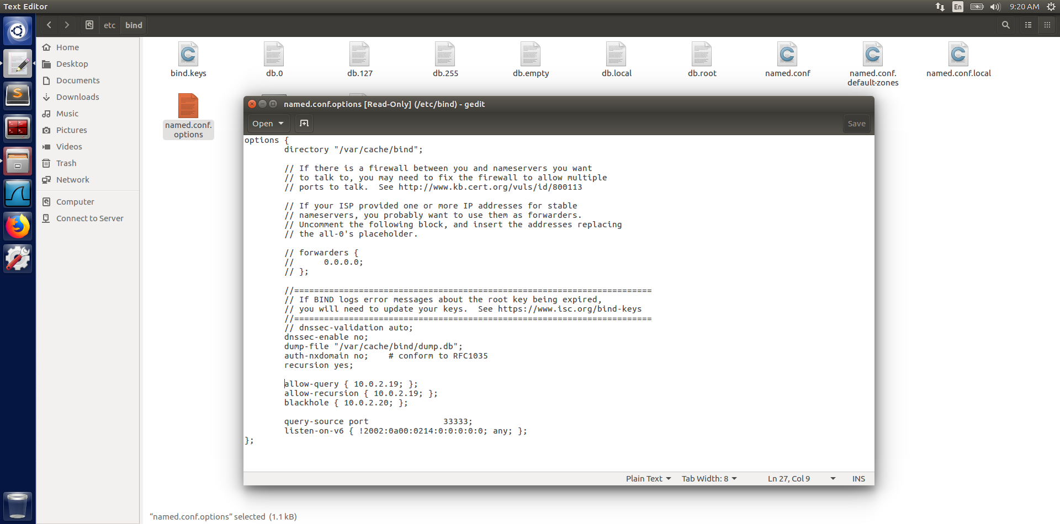

This is from the **Secure DNS Server** machine.

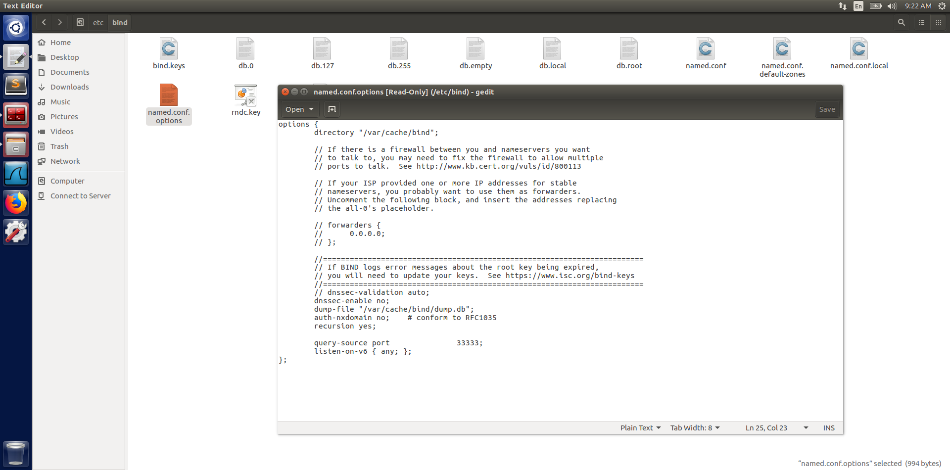

This is from the **Normal DNS Server** machine.

**Demonstration Video Link:** <https://youtu.be/1hZ89F8APoE>

**References:**

* <https://datatracker.ietf.org/doc/html/rfc1035>
* <https://w3.cs.jmu.edu/kirkpams/OpenCSF/Books/csf/html/index.html>
* Wenliang Du - Computer & Internet Security_ A Hands-on Approach-Wenliang Du (2019)